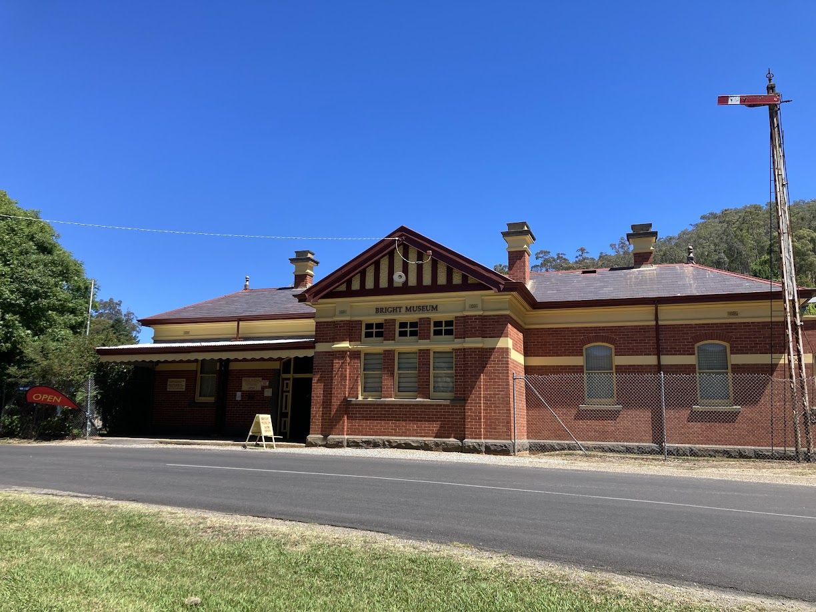
b

BRIGHT & DISTRICT HISTORICAL SOCIETY INC MEMBERSHIP
Your membership includes both our newsletter via email (or, for an extra fee, a mailed copy) and minutes of our meeting (if you wish)
NAME………………………………………………………………………………………………………………..
ADDRESS……………………………………………………………………………………………………………
EMAIL………………………………………………………………………………………………………………..
Do you wish to receive minutes of meetings? YES/NO
Single $20 Family $30 (Circle)
Newsletter by post? Extra $10
DONATION (Always appreciated) $...............
Total: $................
Membership is financial year from 1st July to 30th June
Please send payment to Treasurer, BDHS, PO BOX 265, Bright, Vic, 3741, or pay online by direct deposit into Bendigo Bank BSB 633 000
BDHS Account No 207 883 489 with your surname and ‘membership’ in the reference line.

If you choose to pay electronically and you are a new member, please send this form to the Treasurer so we have your contact details.
MEMBERS HAVE FREE ENTRY TO THE MUSEUM AND BATTERY DURING OPENING HOURS.

